**LAPORAN UAS PEMROGRAMAN WEB FRAMEWORK**

**APLIKASI PENJUALAN KENDARAAN**

# **COVER**

Diajukan untuk memenuhi tugas ujian akhir sekolah semester 7

dengan Dosen Pengampu: Harminto Mulyo, S.kom., M.kom



Disusun oleh :

NAMA : Samsul Ma’arif

NIM : 161240000501

**PROGRAM STUDI TEKNIK INFORMATIKA**

**FAKULTAS SAINS DAN TEKNOLOGI**

**UNIVERSITAS ISLAM NAHDLATUL ULAMA JEPARA**

**2019/2020**

**BAB I**

**CREATE TABEL**

* 1. **Create database kendaraan dan tabel stok_kendaraan.**

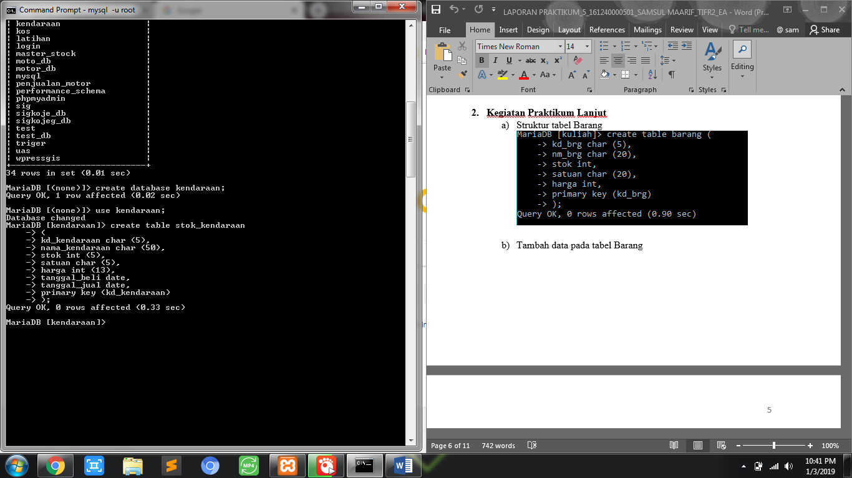

* 1. **Create tabel pembelian_kendaraan.**

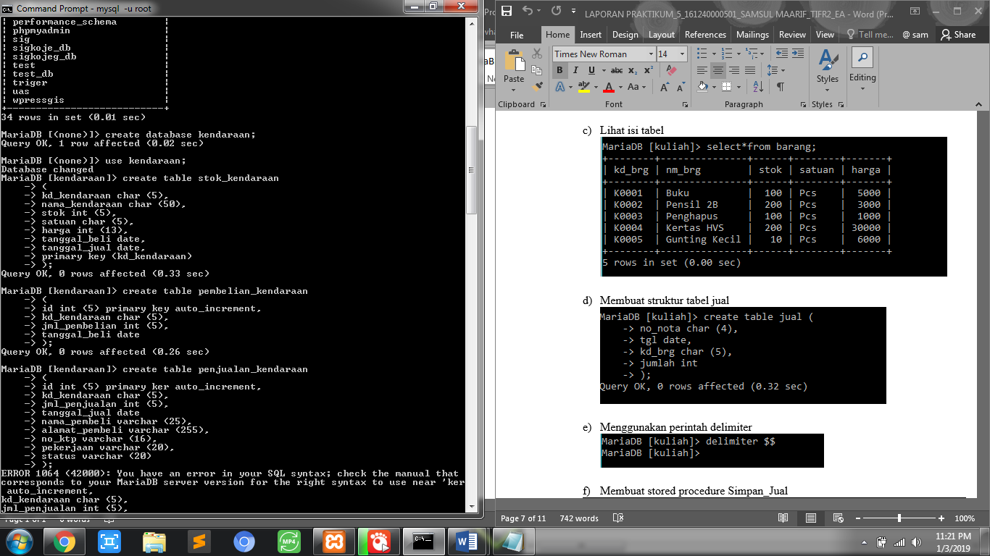

* 1. **Create tabel penjualan_kendaraan.**

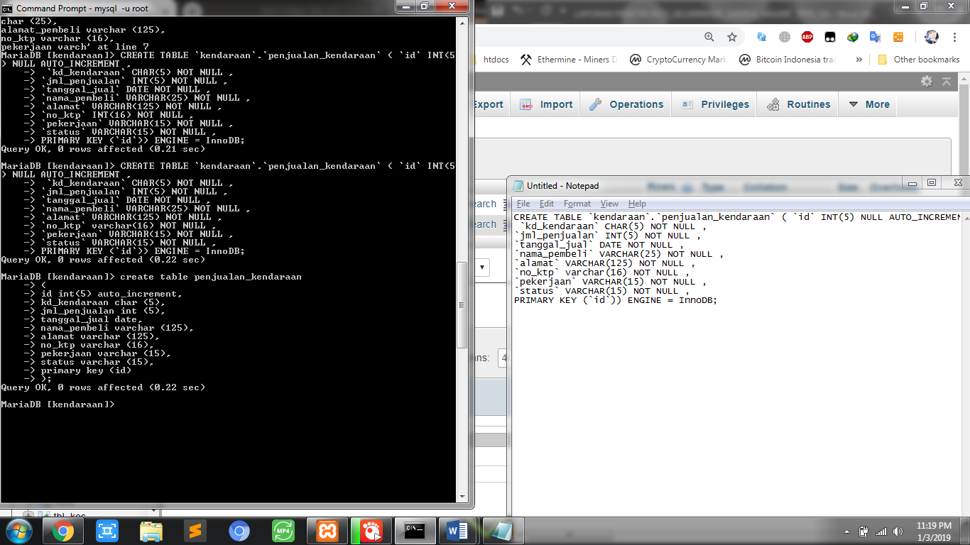

* 1. **Create tabel users.**

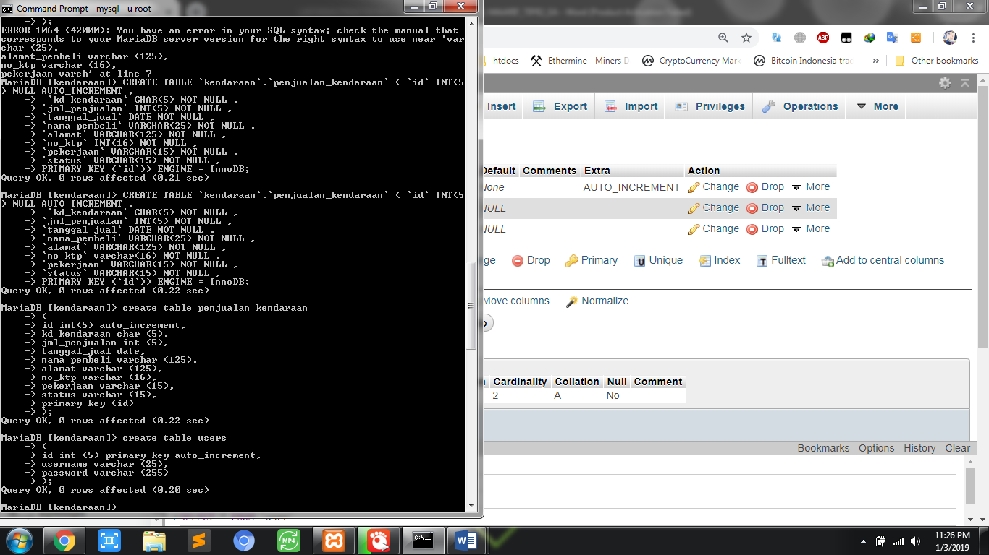

* 1. **Description dari tabel**

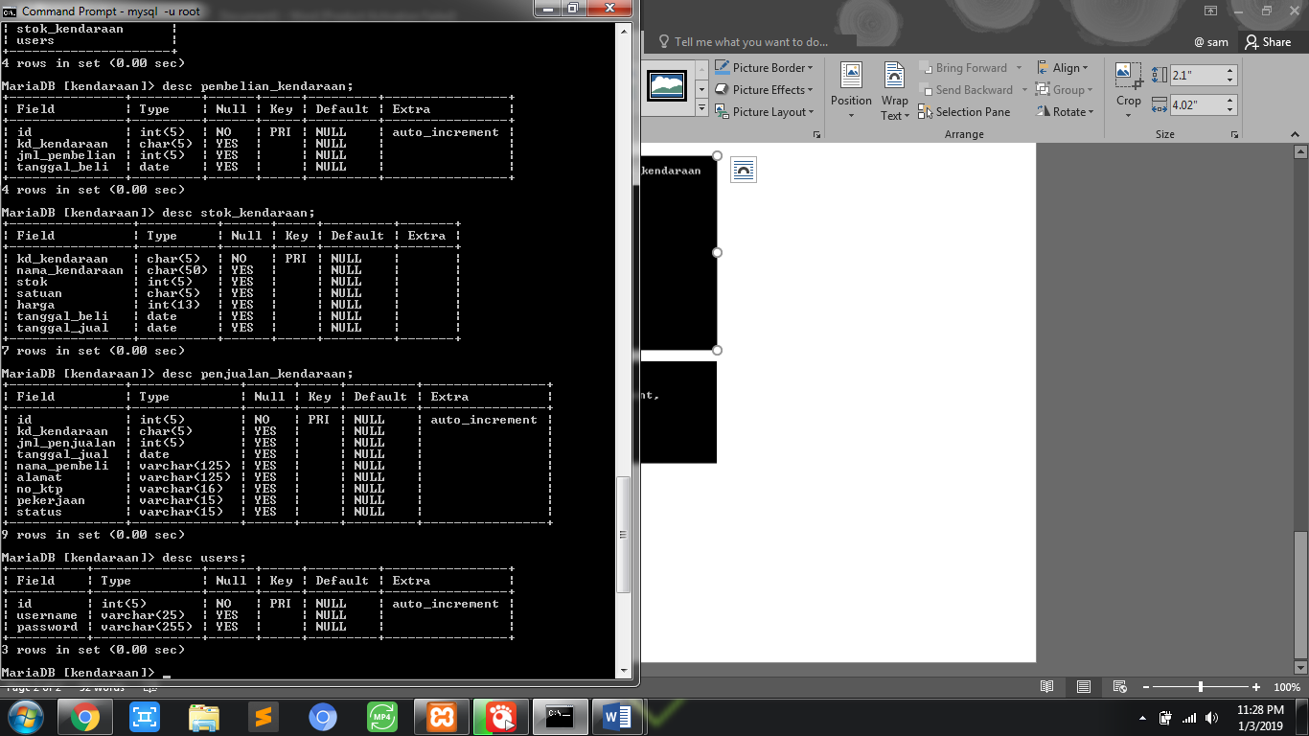

* 1. **Insert tabel stok_kendaraan**

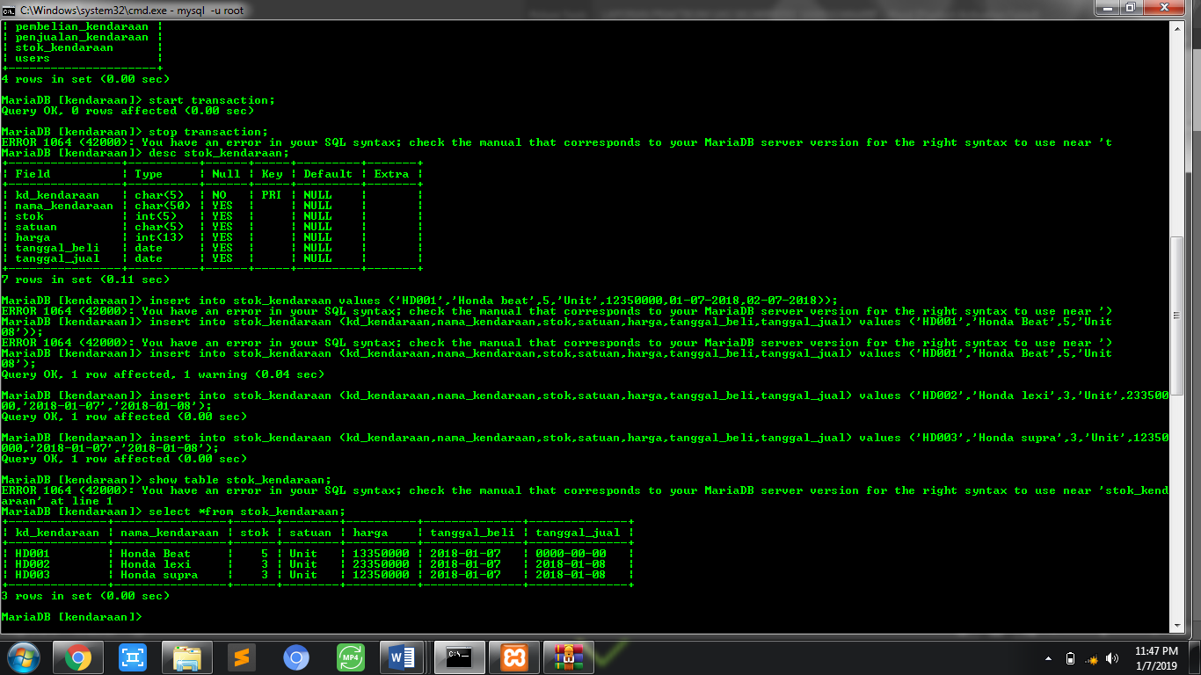

* 1. **Hasil Insert tabel stok_kendaraan**



# **BAB II**

# **TRIGGER, PROCEDURE DATABASE**

* 1. **Trigger pembelian**

Stored procedure dan delimiter untuk menghitung stok barang (tambah dan kurang stok)!

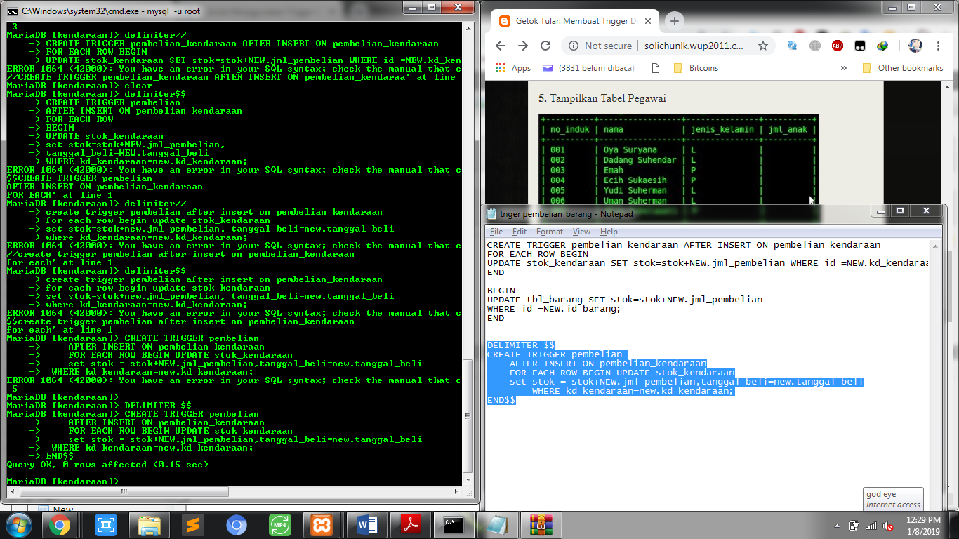

* 1. **Hasil pembelian kendaraan**

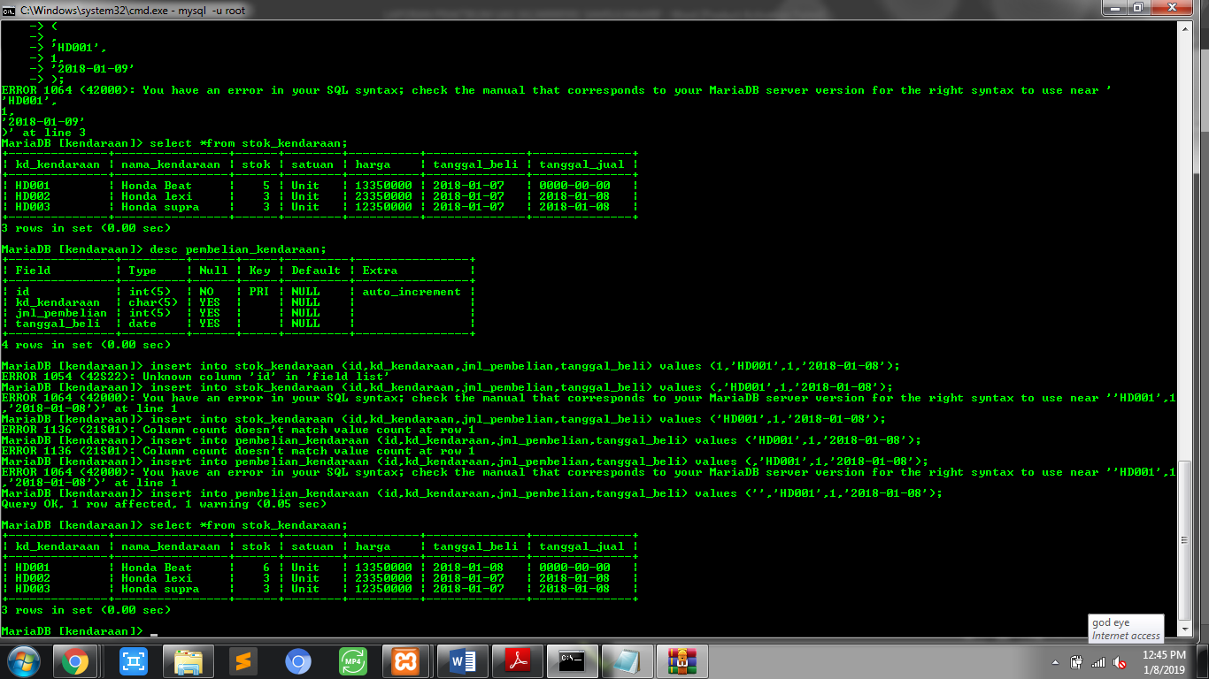

Bisa kita lihat dari hasil dibawah bahwa stok dapat bertambah ketika kita melakukan insert kedalam tabel pembelian kendaraan.



* 1. **Trigger Penjualan**

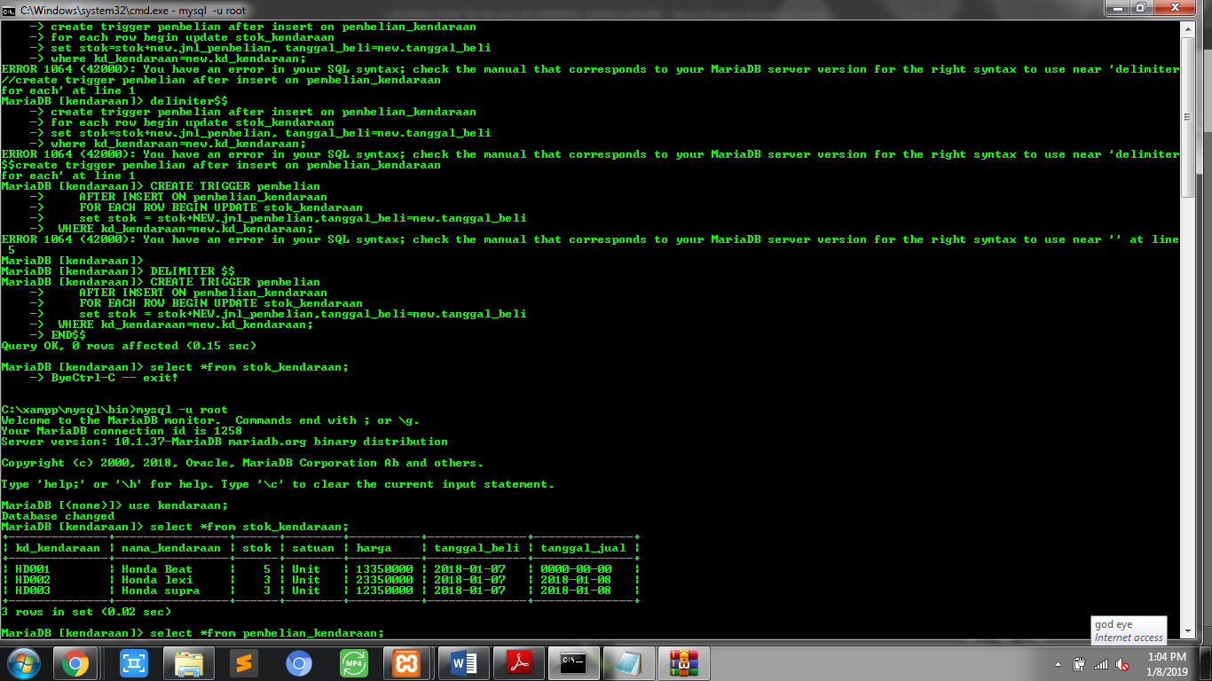

* 1. **Hasil Penjualan kendaraan**

Bisa kita lihat dari hasil dibawah bahwa stok kendaraan dapat berkurang ketika kita melakukan insert kedalam tabel penjulan sebanyak 3 unit pada kode kendaraan HD001.

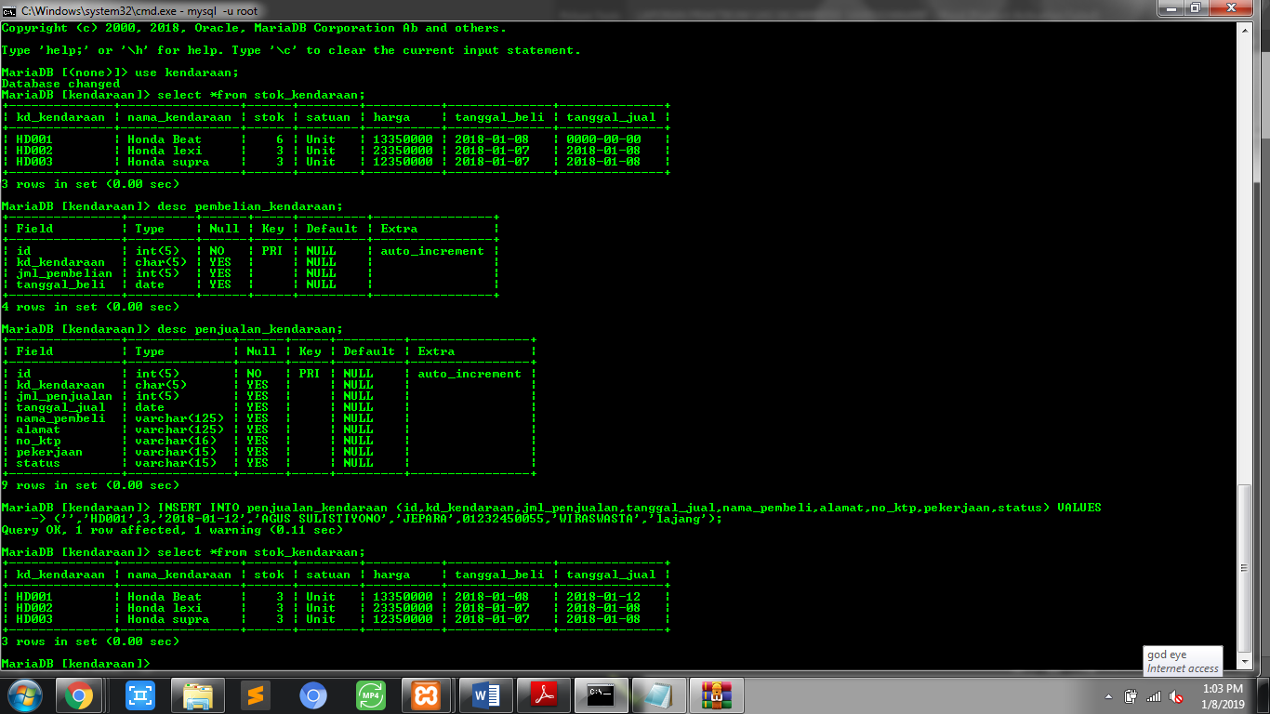

* 1. **Procedure transaksi penjualan**

Procedure transaksi penjualan untuk menampilkan jumlah transaksi per-hari!

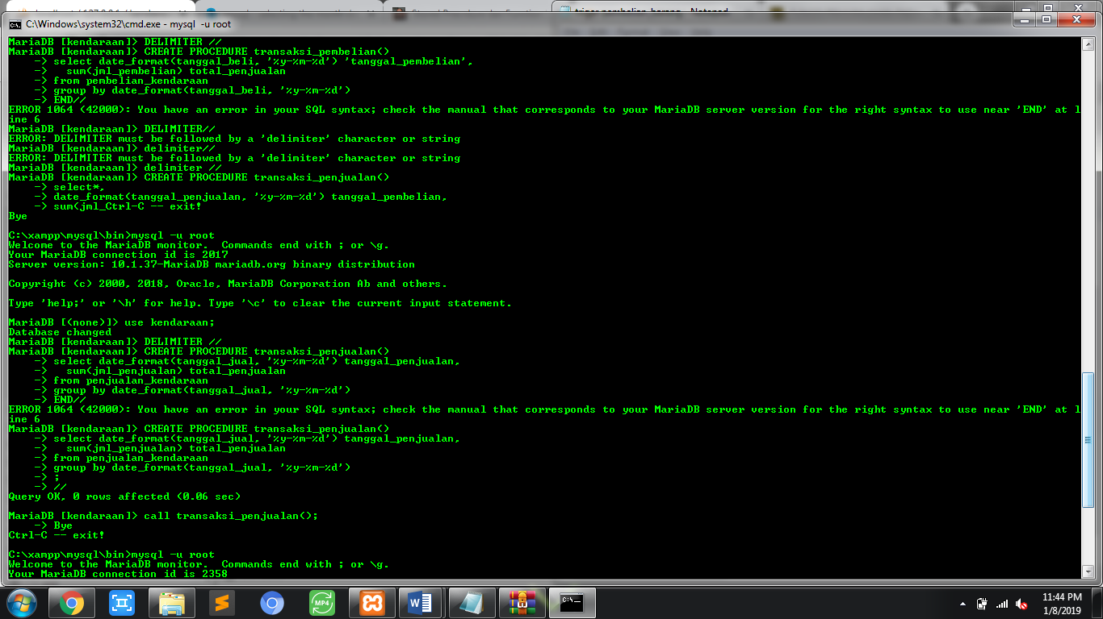

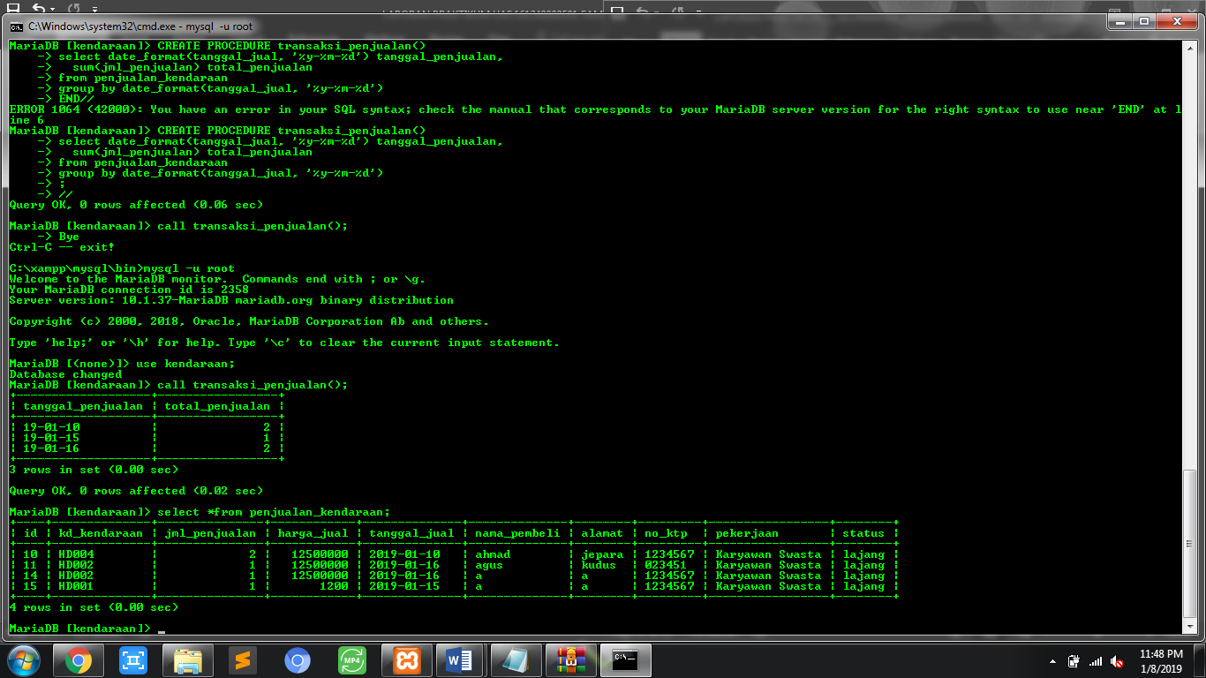

* 1. **Procedure transaksi pembelian**

Procedure transaksi pembelian untuk menampilkan jumlah transaksi per-hari!

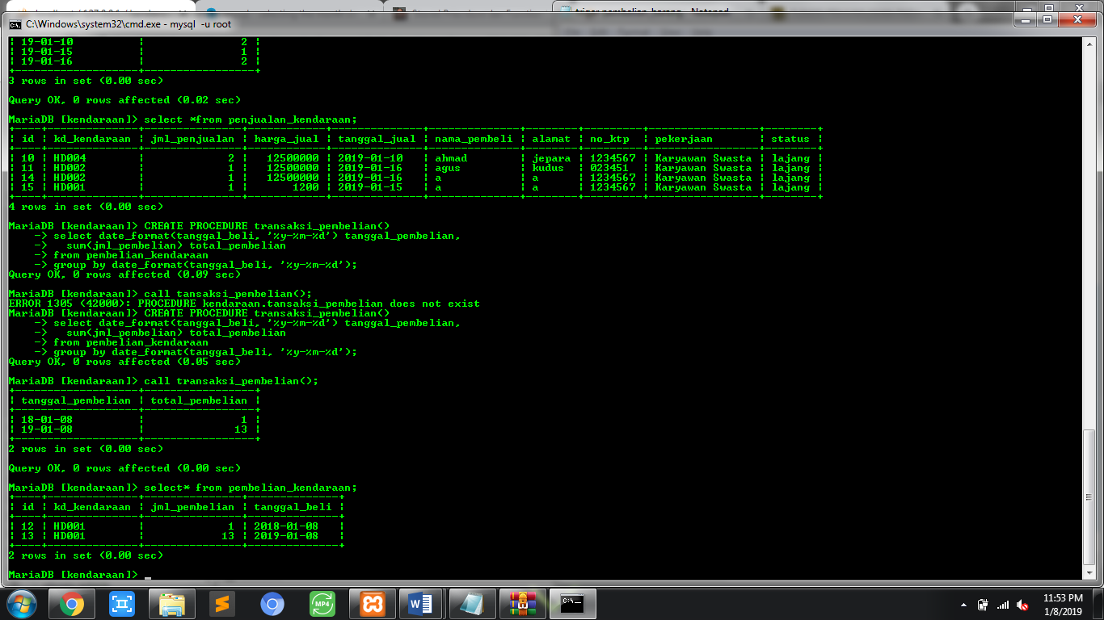

* 1. **Procedure Total Pembayaran**

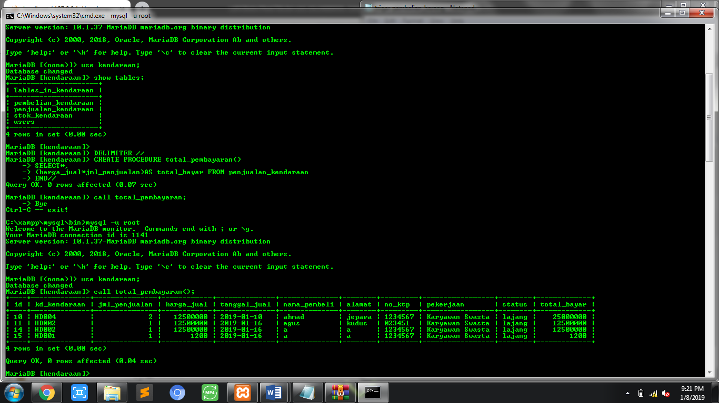

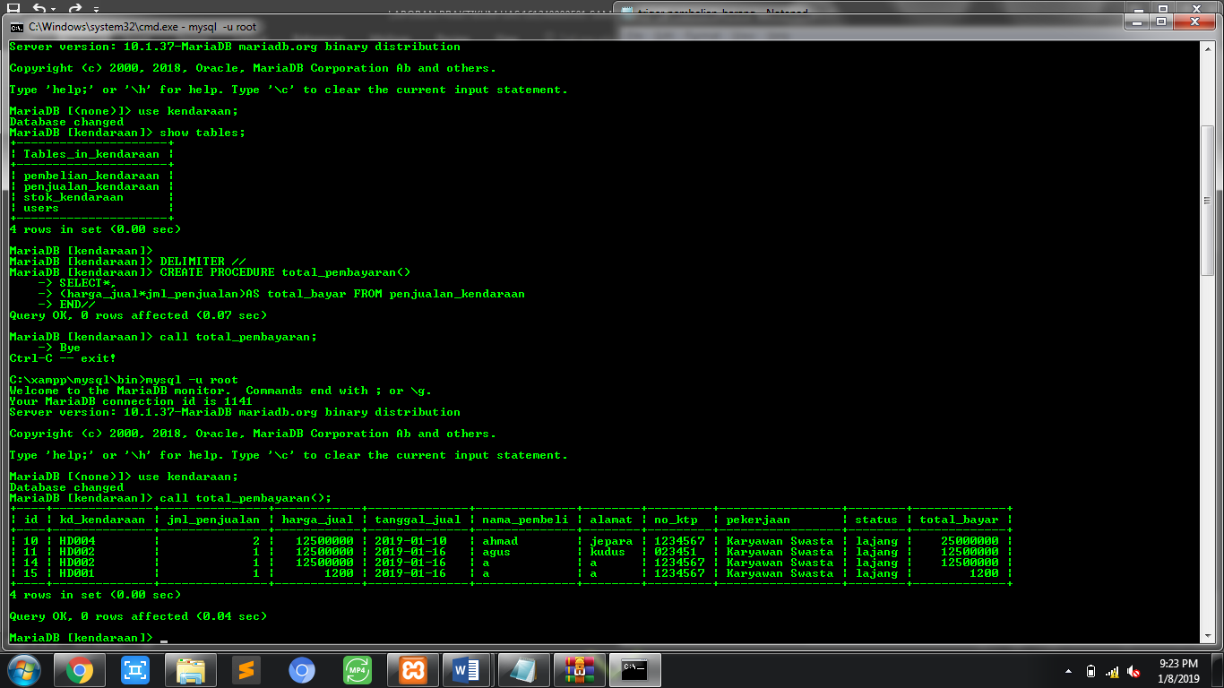

* 1. **Procedure Perhitungan diskon**

Karena pada soal bertuliskan jika total transaksi lebih dari 200.000 maka akan mendapatkan diskon 10% jadi saya mencoba untuk melakukan penjualan kendaraan dengan harga 1200 supaya untuk membuktikan kalau procedure yang sudah saya benar.

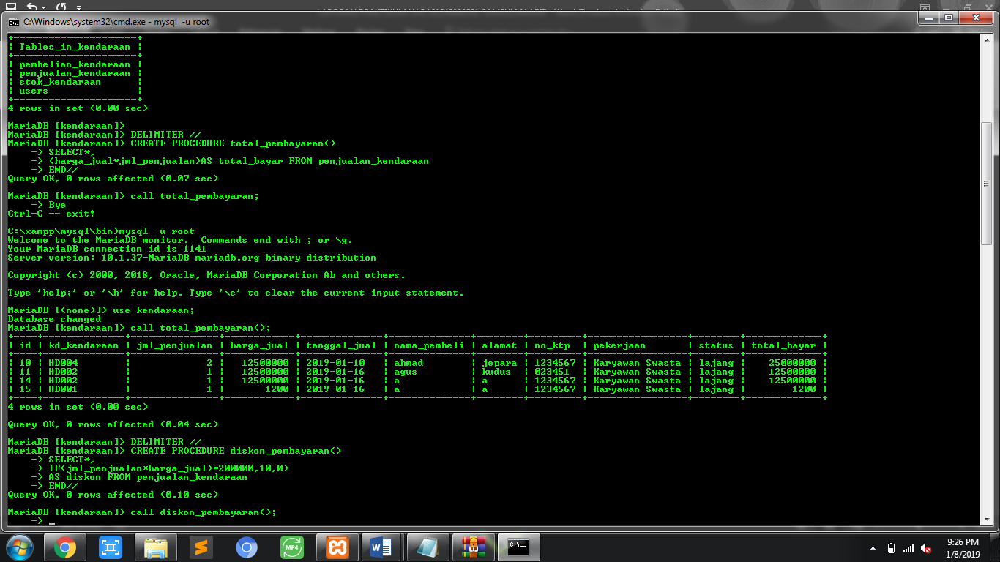

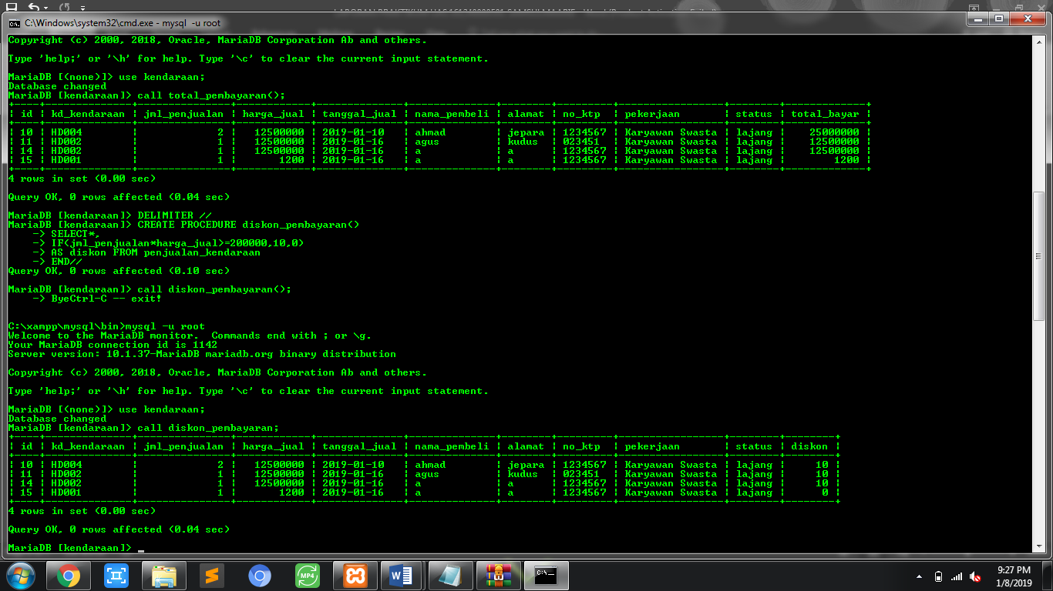

# **BAB III**

# **RELASI TABEL**

1. 1. **Tahap 1: Penentuan Entities**

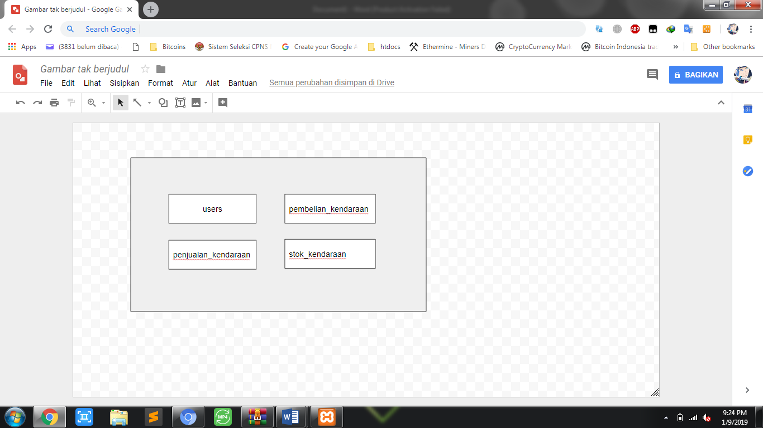

* 1. **Tahap 2 : Penentuan Atribut**

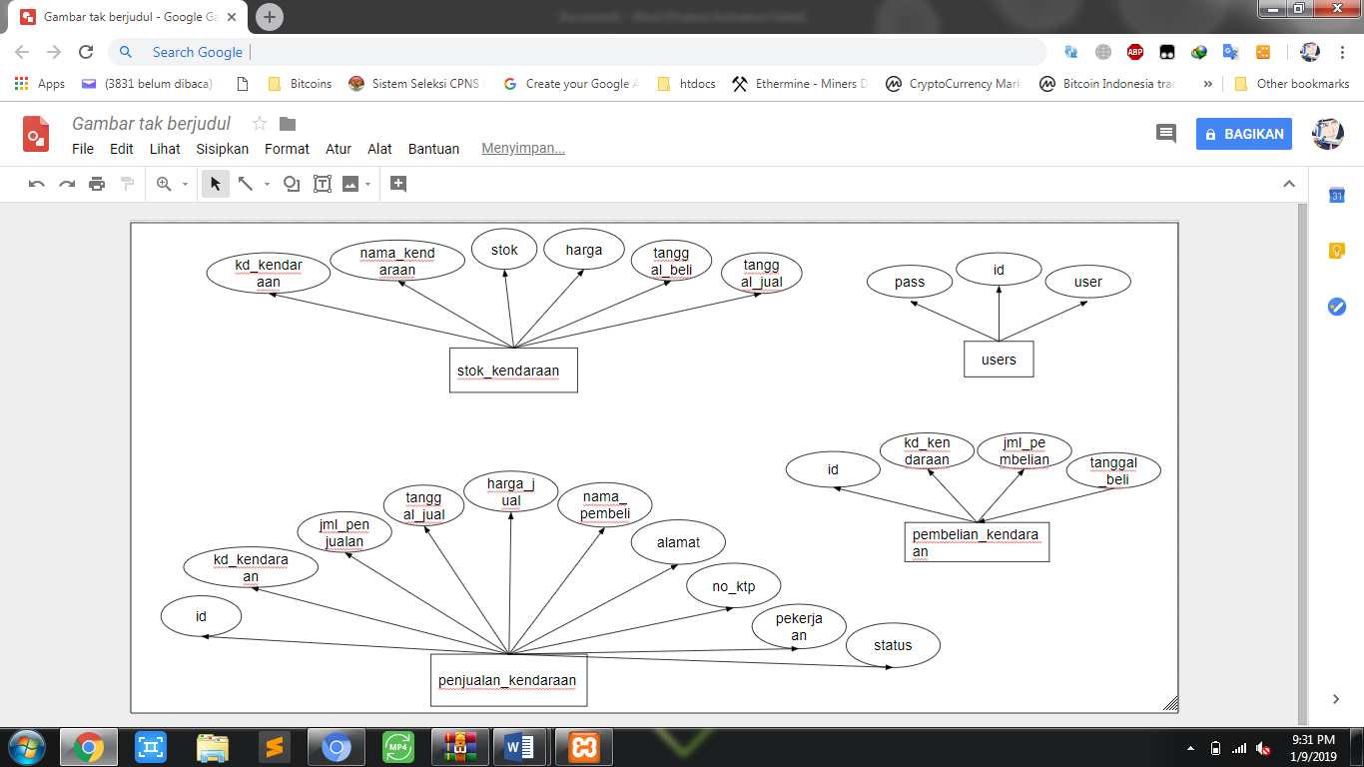

* 1. **Tahap 3 : Penentuan Kardinalitas Relasi**

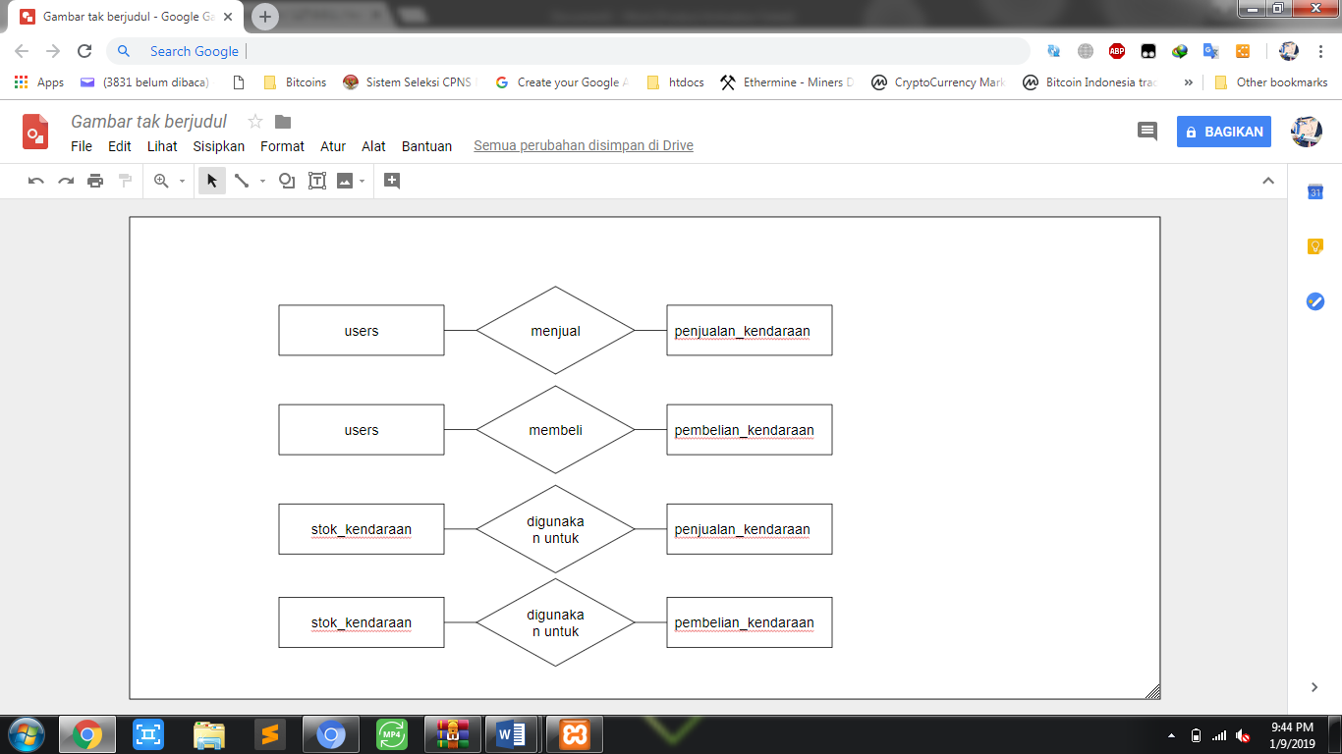

* 1. **Tahap 4 : ERD**

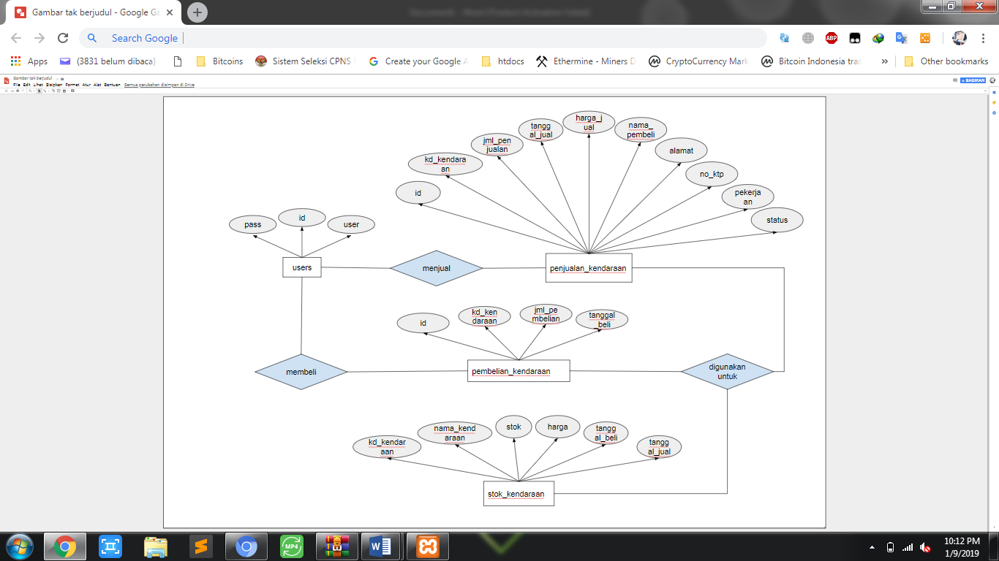

# **BAB IV**

# **SCRIPT APLIKASI**

* 1. **Struktur Script Aplikasi Penjualan Kendaraan**

Pada folder controller untuk admin dipisahkan dengan file dashboard atau pemnggilan awal script aplikasi.

Folder model juga dipisahkan anatara model penjualan dan model login untuk “penjualan_m.php” berada didalam folder admin.

Untuk view saya pisahkan di folder admin dan di luar folder admin untuk folder admin berisikan view dari home, pembelian, penjualan dan stok kendaraan.

Didalam folder admin terdapat folder templates yang berisikan file footer dan header saya sengaja memisahkan file atau script ini untuk mempermudah dalam pemanggilan script baik itu css, maupun jquerynya.

Untuk view login saya taruh diluar folder dalam kata lain saya taruh diluar karena view ini akan ditampilkan terlebih dahulu sebelum admin masuk ke dashboard admin.

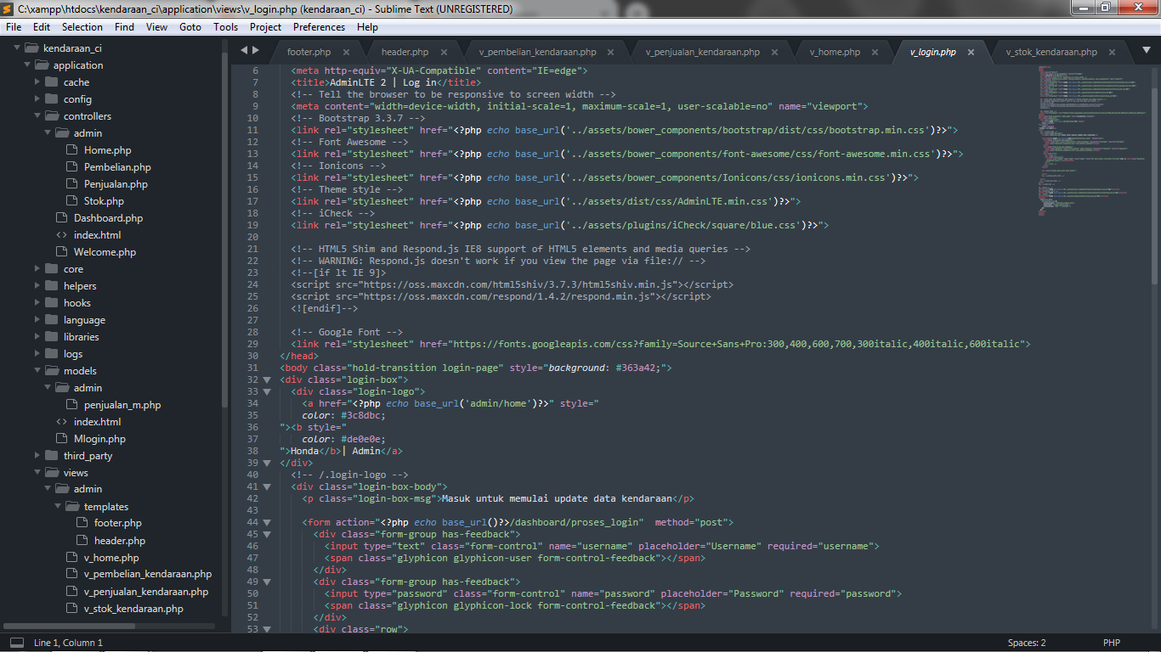

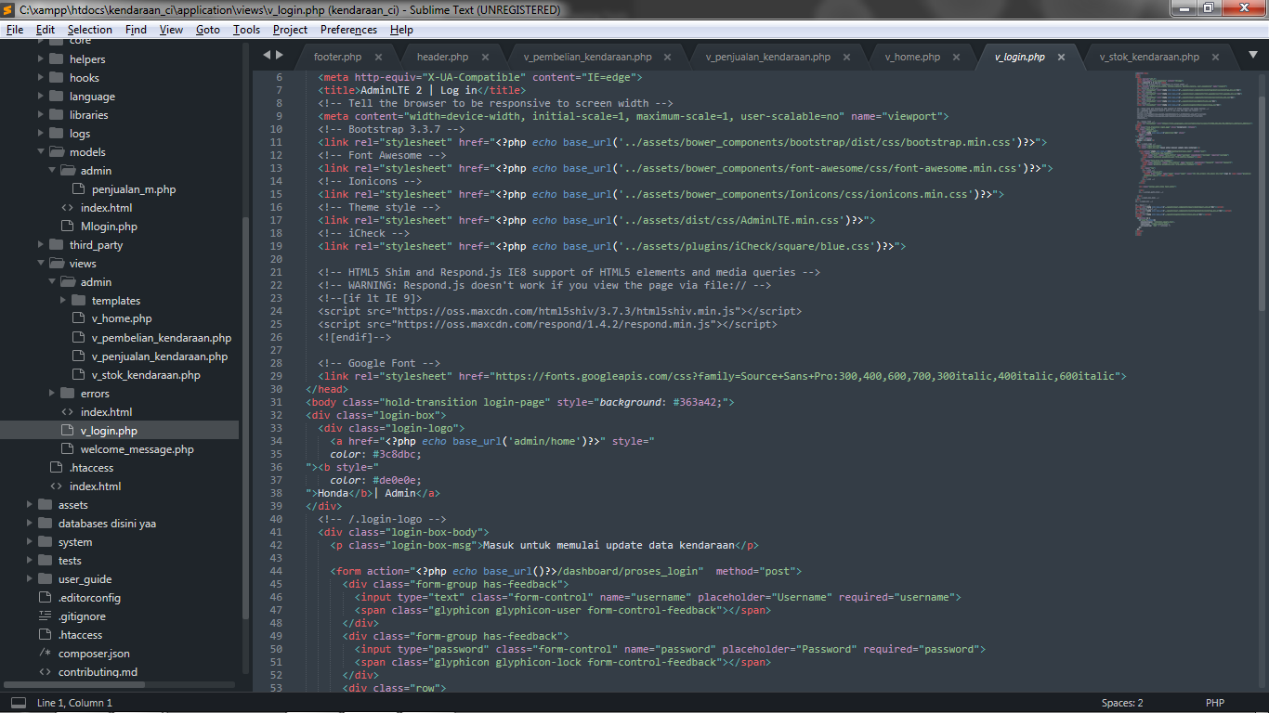

* 1. **Script Controller Home**

<?php

defined('BASEPATH') OR exit('No direct script access allowed');

class Home extends CI_Controller {

public function __construct()

{

parent::__construct();

$this->load->library('session');

$this->load->model('admin/penjualan_m');

}

public function index()

{

if ($this->session->userdata('user_login')==null)

{

redirect('dashboard/login');

}

$this->load->view('admin/templates/header');

$data["total_barang"]=$this->penjualan_m->total_barang();

$data["total_pembelian"]=$this->penjualan_m->total_pembelian();

$data["total_penjualan"]=$this->penjualan_m->total_penjualan();

$data["total_jual_member"]=$this->penjualan_m->total_jual_member();

$data['transaksi_pembelian']=$this->penjualan_m->transaksi_pembelian();

$data['transaksi_penjualan']=$this->penjualan_m->transaksi_penjualan();

$this->load->view('admin/v_home',$data);

$this->load->view('admin/templates/footer');

}

}

* 1. **Script Controller Pembelian**

<?php

defined('BASEPATH') OR exit('No direct script access allowed');

class Pembelian extends CI_Controller {

public function __construct()

{

parent::__construct();

$this->load->library('session');

$this->load->model('admin/penjualan_m');

}

public function index()

{

if ($this->session->userdata('user_login')==null)

{

redirect('dashboard/login');

}

$this->load->view('admin/templates/header');

$data["pembelian"]= $this->penjualan_m->get_all_pembelian();

$data["total_pembelian"]= $this->penjualan_m->total_pembelian();

$this->load->view('admin/v_pembelian_kendaraan',$data);

$this->load->view('admin/templates/footer');

}

public function tambah()

{

$data = array('judul' => 'Tambah Data');

$this->load->view('admin/templates/header');

$data["barang"] = $this->penjualan_m->get_all_barang();

$data["total_barang"]= $this->penjualan_m->total_barang();

$this->load->view('admin/v_stok_kendaraan', $data);

$this->load->view('admin/templates/footer');

}

public function simpan()

{

$data = array(

'id' => ''

, 'kd_kendaraan' => $this->input->post('kd_kendaraan')

, 'jml_pembelian' => $this->input->post('jml')

, 'tanggal_beli' => $this->input->post('tanggal')

);

$this->penjualan_m->simpan_data_pembelian($data);

}

public function hapus()

{

$data["kd_kendaraan"]= $this->penjualan_m->hapus_data_pembelian();

}

}

/* End of file Pembelian.php */

/* Location: ./application/controllers/admin/Pembelian.php */

public function simpan()

{

$data = array(

'id' => ''

, 'kd_kendaraan' => $this->input->post('kd_kendaraan')

, 'jml_pembelian' => $this->input->post('jml')

, 'tanggal_beli' => $this->input->post('tanggal')

);

$this->penjualan_m->simpan_data_pembelian($data);

}

public function hapus()

{

$data["kd_kendaraan"]= $this->penjualan_m->hapus_data_pembelian();

}

}

* 1. **Script Controller Penjualan**

<?php

defined('BASEPATH') OR exit('No direct script access allowed');

class Penjualan extends CI_Controller {

public function __construct()

{

parent::__construct();

$this->load->library('session');

$this->load->model('admin/penjualan_m');

}

public function index()

{

if ($this->session->userdata('user_login')==null)

{

redirect('dashboard/login');

}

$this->load->view('admin/templates/header');

$data["penjualan"]=$this->penjualan_m->get_all_penjualan();

$data["total"]=$this->penjualan_m->total_penjualan();

$data["diskon_pembayaran"]=$this->penjualan_m->diskon_pembayaran();

$this->load->view('admin/v_penjualan_kendaraan',$data);

$this->load->view('admin/templates/footer');

}

public function tambah()

{

$data = array('judul' => 'Tambah Data');

$this->load->view('admin/templates/header');

$data["barang"] = $this->penjualan_m->get_all_barang();

$data["total_barang"]= $this->penjualan_m->total_barang();

$this->load->view('admin/v_stok_kendaraan', $data);

$this->load->view('admin/templates/footer');

}

public function simpan()

{

$data = array(

'id' => ''

, 'kd_kendaraan' => $this->input->post('kd_kendaraan')

, 'jml_penjualan' => $this->input->post('jml')

, 'nama_pembeli' => $this->input->post('nama')

, 'alamat' => $this->input->post('alamat')

, 'harga_jual' => $this->input->post('harga')

, 'no_ktp' => $this->input->post('no_ktp')

, 'pekerjaan' => $this->input->post('pekerjaan')

, 'tanggal_jual' => $this->input->post('tanggal_jual')

, 'status' => $this->input->post('status')

);

$this->penjualan_m->simpan_data_penjualan($data);

}

}

public function tambah()

{

$data = array('judul' => 'Tambah Data');

$this->load->view('admin/templates/header');

$data["barang"] = $this->penjualan_m->get_all_barang();

$data["total_barang"]= $this->penjualan_m->total_barang();

$this->load->view('admin/v_stok_kendaraan', $data);

$this->load->view('admin/templates/footer');

}

public function simpan()

{

$data = array(

'id' => ''

, 'kd_kendaraan' => $this->input->post('kd_kendaraan')

, 'jml_penjualan' => $this->input->post('jml')

, 'nama_pembeli' => $this->input->post('nama')

, 'alamat' => $this->input->post('alamat')

, 'harga_jual' => $this->input->post('harga')

, 'no_ktp' => $this->input->post('no_ktp')

, 'pekerjaan' => $this->input->post('pekerjaan')

, 'tanggal_jual' => $this->input->post('tanggal_jual')

, 'status' => $this->input->post('status')

);

$this->penjualan_m->simpan_data_penjualan($data);

}

}

defined('BASEPATH') OR exit('No direct script access allowed');

class Penjualan extends CI_Controller {

public function __construct()

{

parent::__construct();

$this->load->library('session');

$this->load->model('admin/penjualan_m');

}

public function index()

{

if ($this->session->userdata('user_login')==null)

{

redirect('dashboard/login');

}

$this->load->view('admin/templates/header');

$data["penjualan"]=$this->penjualan_m->get_all_penjualan();

$data["total"]=$this->penjualan_m->total_penjualan();

$data["diskon_pembayaran"]=$this->penjualan_m->diskon_pembayaran();

$this->load->view('admin/v_penjualan_kendaraan',$data);

$this->load->view('admin/templates/footer');

}

public function tambah()

{

$data = array('judul' => 'Tambah Data');

$this->load->view('admin/templates/header');

$data["barang"] = $this->penjualan_m->get_all_barang();

$data["total_barang"]= $this->penjualan_m->total_barang();

$this->load->view('admin/v_stok_kendaraan', $data);

$this->load->view('admin/templates/footer');

}

public function simpan()

{

$data = array(

'id' => ''

, 'kd_kendaraan' => $this->input->post('kd_kendaraan')

, 'jml_penjualan' => $this->input->post('jml')

, 'nama_pembeli' => $this->input->post('nama')

, 'alamat' => $this->input->post('alamat')

, 'harga_jual' => $this->input->post('harga')

, 'no_ktp' => $this->input->post('no_ktp')

, 'pekerjaan' => $this->input->post('pekerjaan')

, 'tanggal_jual' => $this->input->post('tanggal_jual')

, 'status' => $this->input->post('status')

);

$this->penjualan_m->simpan_data_penjualan($data);

}

}

* 1. **Script Controller Stok**

<?php

class Stok extends CI_Controller{

public function __construct()

{

parent::__construct();

$this->load->library('session');

$this->load->model('admin/penjualan_m');

}

public function index()

{

if ($this->session->userdata('user_login')==null) {

redirect('dashboard/login');

}

$this->load->view('admin/templates/header');

$data["barang"] = $this->penjualan_m->get_all_barang();

$data["total_barang"]= $this->penjualan_m->total_barang();

$this->load->view('admin/v_stok_kendaraan',$data);

$this->load->view('admin/templates/footer');

}

}

* 1. **Script Controller Dashboard**

<?php if ( ! defined('BASEPATH')) exit('No direct script access allowed');

class Dashboard extends CI_Controller {

public function __construct()

{

parent::__construct();

$this->load->library('session');

}

public function index()

{

if ($this->session->userdata('user_login')==null) {

redirect('dashboard/login');

}

$this->load->view('dashboard');

}

public function login()

{

$this->load->view('v_login');

}

public function proses_login()

{

$this->load->model('mlogin');

$cek = $this->mlogin->cek_user();

if ($cek=='1') {

redirect('admin/home');

}else{

echo "username atau password tidak cocok";

}

}

public function logout()

{

$this->session->sess_destroy();

redirect('dashboard','refresh');

}

}

public function proses_login()

{

$this->load->model('mlogin');

$cek = $this->mlogin->cek_user();

if ($cek=='1') {

redirect('admin/home');

}else{

echo "username atau password tidak cocok";

}

}

public function logout()

{

$this->session->sess_destroy();

redirect('dashboard','refresh');

}

}

* 1. **Script Model Mlogin**

<?php

defined('BASEPATH') OR exit('No direct script access allowed');

class Mlogin extends CI_Model {

public function cek_user()

{

$this->db->where('user', $this->input->post('username'));

$this->db->where('pass', md5($this->input->post('password')));

$q = $this->db->get('users',1);

$status = '0';

if ($q->num_rows()>0) {

$session = array(

'user_login' => $q->row('user'),

'password_login' => $q->row('pass'),

);

$this->session->set_userdata($session);

$status = '1';

}else{

$status = '0';

}

return $status;

}

}

/* End of file Mlogin.php */

/* Location: ./application/models/Mlogin.php */

* 1. **Script Model penjualan_m**

<?php

defined('BASEPATH') OR exit('No direct script access allowed');

class Penjualan_m extends CI_Model {

//tampil data

public function get_all_barang(){

return $this->db->get('stok_kendaraan')->result();

}

public function total_barang(){

$query = $this->db->query("SELECT stok_kendaraan.stok, SUM(stok) as total FROM stok_kendaraan");

return $query->result();

}

public function get_all_pembelian()

{

$this->db->select('*');

$this->db->from('pembelian_kendaraan');

$this->db->join('stok_kendaraan','stok_kendaraan.kd_kendaraan = pembelian_kendaraan.kd_kendaraan');

return $this->db->get()->result();

}

public function total_pembelian(){

$query = $this->db->query("SELECT pembelian_kendaraan.jml_pembelian, SUM(jml_pembelian) as total FROM pembelian_kendaraan");

return $query->result();

}

public function hapus_data_pembelian()

{

$kd_kendaraan = $this->uri->segment(3);

$pmb = $this->db->where('kd_kendaraan',$kd_kendaraan)->delete('pembelian_kendaraan');

if ($pmb) {

redirect('admin/pembelian');

}

}

public function simpan_data_pembelian($data)

{

$q = $this->db->insert('pembelian_kendaraan', $data);

if ($q) {

redirect('admin/pembelian/tambah');

}else{

redirect('admin/pembelian/tambah');

}

}

public function simpan_data_penjualan($data)

{

$q = $this->db->insert('penjualan_kendaraan', $data);

if ($q) {

redirect('admin/penjualan/tambah');

}else{

redirect('admin/penjualan/tambah');

}

}

public function transaksi_pembelian(){

// menjalankan stored procedure tampil_penerbit()

$sql_query=$this->db->query("call transaksi_pembelian()");

mysqli_next_result( $this->db->conn_id);

if($sql_query->num_rows()>0){

return $sql_query->result_array();

}

}

public function transaksi_penjualan(){

// menjalankan stored procedure tampil_penerbit()

$sql_query=$this->db->query("call transaksi_penjualan()");

mysqli_next_result( $this->db->conn_id);

if($sql_query->num_rows()>0){

return $sql_query->result_array();

}

}

public function get_all_penjualan()

{

$this->db->select('*');

$this->db->from('penjualan_kendaraan');

$this->db->join('stok_kendaraan','stok_kendaraan.kd_kendaraan = penjualan_kendaraan.kd_kendaraan');

return $this->db->get()->result();

}

public function total_penjualan(){

$query = $this->db->query("SELECT penjualan_kendaraan.jml_penjualan, SUM(jml_penjualan) as total FROM penjualan_kendaraan");

return $query->result();

}

public function diskon_pembayaran(){

// menjalankan stored procedure tampil_penerbit()

$sql_query=$this->db->query("call diskon_pembayaran()");

mysqli_next_result( $this->db->conn_id);

if($sql_query->num_rows()>0){

return $sql_query->result_array();

}

}

public function total_jual_member(){

$query = $this->db->query("SELECT penjualan_kendaraan.nama_pembeli, count(nama_pembeli) as total FROM penjualan_kendaraan");

return $query->result();

}

// public function total_bayar (){

// $query = $this->db->query("SELECT id, kd_kendaraan, jml_penjualan, harga_jual, tanggal_jual, nama_pembeli, alamat, no_ktp, pekerjaan, status ,harga_jual*jml_penjualan AS total FROM penjualan_kendaraan");

// return $query->result();

// }

}

**public function hapus_data_pembelian()**

**{**

**$kd_kendaraan = $this->uri->segment(3);**

**$pmb = $this->db->where('kd_kendaraan',$kd_kendaraan)->delete('pembelian_kendaraan');**

**if ($pmb) {**

**redirect('admin/pembelian');**

**}**

**}**

**public function simpan_data_pembelian($data)**

**{**

**$q = $this->db->insert('pembelian_kendaraan', $data);**

**if ($q) {**

**redirect('admin/pembelian/tambah');**

**}else{**

**redirect('admin/pembelian/tambah');**

**}**

**}**

**public function simpan_data_penjualan($data)**

**{**

**$q = $this->db->insert('penjualan_kendaraan', $data);**

**if ($q) {**

**redirect('admin/penjualan/tambah');**

**}else{**

**redirect('admin/penjualan/tambah');**

**}**

**}**

**public function transaksi_pembelian(){**

**// menjalankan stored procedure tampil_penerbit()**

**$sql_query=$this->db->query("call transaksi_pembelian()");**

**mysqli_next_result( $this->db->conn_id);**

**if($sql_query->num_rows()>0){**

**return $sql_query->result_array();**

**}**

**}**

**public function transaksi_penjualan(){**

**// menjalankan stored procedure tampil_penerbit()**

**$sql_query=$this->db->query("call transaksi_penjualan()");**

**mysqli_next_result( $this->db->conn_id);**

**if($sql_query->num_rows()>0){**

**return $sql_query->result_array();**

**}**

**}**

**public function get_all_penjualan()**

**{**

**$this->db->select('*');**

**$this->db->from('penjualan_kendaraan');**

**$this->db->join('stok_kendaraan','stok_kendaraan.kd_kendaraan = penjualan_kendaraan.kd_kendaraan');**

**return $this->db->get()->result();**

**}**

**public function total_penjualan(){**

**$query = $this->db->query("SELECT penjualan_kendaraan.jml_penjualan, SUM(jml_penjualan) as total FROM penjualan_kendaraan");**

**return $query->result();**

**}**

**public function diskon_pembayaran(){**

**// menjalankan stored procedure tampil_penerbit()**

**$sql_query=$this->db->query("call diskon_pembayaran()");**

**mysqli_next_result( $this->db->conn_id);**

**if($sql_query->num_rows()>0){**

**return $sql_query->result_array();**

**}**

**}**

**public function total_jual_member(){**

**$query = $this->db->query("SELECT penjualan_kendaraan.nama_pembeli, count(nama_pembeli) as total FROM penjualan_kendaraan");**

**return $query->result();**

**}**

**public function transaksi_pembelian(){**

**// menjalankan stored procedure tampil_penerbit()**

**$sql_query=$this->db->query("call transaksi_pembelian()");**

**mysqli_next_result( $this->db->conn_id);**

**if($sql_query->num_rows()>0){**

**return $sql_query->result_array();**

**}**

**}**

**public function transaksi_penjualan(){**

**// menjalankan stored procedure tampil_penerbit()**

**$sql_query=$this->db->query("call transaksi_penjualan()");**

**mysqli_next_result( $this->db->conn_id);**

**if($sql_query->num_rows()>0){**

**return $sql_query->result_array();**

**}**

**}**

**public function get_all_penjualan()**

**{**

**$this->db->select('*');**

**$this->db->from('penjualan_kendaraan');**

**$this->db->join('stok_kendaraan','stok_kendaraan.kd_kendaraan = penjualan_kendaraan.kd_kendaraan');**

**return $this->db->get()->result();**

**}**

**public function total_penjualan(){**

**$query = $this->db->query("SELECT penjualan_kendaraan.jml_penjualan, SUM(jml_penjualan) as total FROM penjualan_kendaraan");**

**return $query->result();**

**}**

**public function diskon_pembayaran(){**

**// menjalankan stored procedure tampil_penerbit()**

**$sql_query=$this->db->query("call diskon_pembayaran()");**

**mysqli_next_result( $this->db->conn_id);**

**if($sql_query->num_rows()>0){**

**return $sql_query->result_array();**

**}**

**}**

**public function total_jual_member(){**

**$query = $this->db->query("SELECT penjualan_kendaraan.nama_pembeli, count(nama_pembeli) as total FROM penjualan_kendaraan");**

**return $query->result();**

**}**

* 1. **Script View v_login**

<!DOCTYPE html>

<html>

<head>

<meta charset="utf-8">

<meta http-equiv="X-UA-Compatible" content="IE=edge">

<title>AdminLTE 2 | Log in</title>

<!-- Tell the browser to be responsive to screen width -->

<meta content="width=device-width, initial-scale=1, maximum-scale=1, user-scalable=no" name="viewport">

<!-- Bootstrap 3.3.7 -->

<link rel="stylesheet" href="<?php echo base_url('../assets/bower_components/bootstrap/dist/css/bootstrap.min.css')?>">

<!-- Font Awesome -->

<link rel="stylesheet" href="<?php echo base_url('../assets/bower_components/font-awesome/css/font-awesome.min.css')?>">

<!-- Ionicons -->

<link rel="stylesheet" href="<?php echo base_url('../assets/bower_components/Ionicons/css/ionicons.min.css')?>">

<!-- Theme style -->

<link rel="stylesheet" href="<?php echo base_url('../assets/dist/css/AdminLTE.min.css')?>">

<!-- iCheck -->

<link rel="stylesheet" href="<?php echo base_url('../assets/plugins/iCheck/square/blue.css')?>">

<link rel="stylesheet" href="https://fonts.googleapis.com/css?family=Source+Sans+Pro:300,400,600,700,300italic,400italic,600italic">

</head>

<body class="hold-transition login-page" style="background: #363a42;">

<div class="login-box">

<div class="login-logo">

<a href="<?php echo base_url('admin/home')?>" style="

color: #3c8dbc;

"><b style="

color: #de0e0e;

">Honda</b>| Admin</a>

</div>

<!-- /.login-logo -->

<div class="login-box-body">

<p class="login-box-msg">Masuk untuk memulai update data kendaraan</p>

<form action="<?php echo base_url()?>/dashboard/proses_login" method="post">

<div class="form-group has-feedback">

<input type="text" class="form-control" name="username" placeholder="Username" required="username">

<span class="glyphicon glyphicon-user form-control-feedback"></span>

</div>

<div class="form-group has-feedback">

<input type="password" class="form-control" name="password" placeholder="Password" required="password">

<span class="glyphicon glyphicon-lock form-control-feedback"></span>

</div>

<div class="row">

<!-- /.col -->

<div class="col-xs-12">

<button type="submit" name="login" Value="login" class="btn btn-primary btn-block btn-flat">Sign In <span class="glyphicon glyphicon-log-in"></span></button>

</div>

<!-- /.col -->

</div>

</form>

<div class="social-auth-links text-center">

</div>

<!-- /.social-auth-links -->

</div>

<!-- /.login-box-body -->

</div>

<!-- /.login-box -->

<!-- jQuery 3 -->

<script src="<?php echo base_url('../assets/bower_components/jquery/dist/jquery.min.js')?>"></script>

<!-- Bootstrap 3.3.7 -->

<script src="<?php echo base_url('../assets/bower_components/bootstrap/dist/js/bootstrap.min.js')?>"></script>

<!-- iCheck -->

<script src="<?php echo base_url('../assets/plugins/iCheck/icheck.min.js')?>"></script>

<script>

$(function () {

$('input').iCheck({

checkboxClass: 'icheckbox_square-blue',

radioClass: 'iradio_square-blue',

increaseArea: '20%' /* optional */

});

});

</script>

</body>

</html>

<div class="social-auth-links text-center">

</div>

<!-- /.social-auth-links -->

</div>

<!-- /.login-box-body -->

</div>

<!-- /.login-box -->

<!-- jQuery 3 -->

<script src="<?php echo base_url('../assets/bower_components/jquery/dist/jquery.min.js')?>"></script>

<!-- Bootstrap 3.3.7 -->

<script src="<?php echo base_url('../assets/bower_components/bootstrap/dist/js/bootstrap.min.js')?>"></script>

<!-- iCheck -->

<script src="<?php echo base_url('../assets/plugins/iCheck/icheck.min.js')?>"></script>

<script>

$(function () {

$('input').iCheck({

checkboxClass: 'icheckbox_square-blue',

radioClass: 'iradio_square-blue',

increaseArea: '20%' /* optional */

});

});

</script>

</body>

</html>

* 1. **. Script View v_pembelian_kendaraan**

<!-- Content Wrapper. Contains page content -->

<div class="content-wrapper">

<!-- Content Header (Page header) -->

<section class="content-header">

<h1>

Data Pembelian Kendaraan

<small>Tabel pembelian kendaraan</small>

</h1>

<ol class="breadcrumb">

<li><a href="#"><i class="fa fa-dashboard"></i> Home</a></li>

<li><a href="#">Data Kendaraan</a></li>

<li class="active">Pembelian kendaraaan</li>

</ol>

</section>

<!-- Main content -->

<section class="content">

<div class="row">

<div class="col-xs-7">

<!-- /.box -->

<div class="box">

<div class="box-header">

<h3 class="box-title">Data Table Pembelian</h3>

</div>

<div class="box-body">

<table id="table-datatables" class="table table-bordered table-striped">

<thead>

<tr>

<th>No</th>

<th>Nama motor</th>

<th>Harga</th>

<th>jumlah pembelian</th>

<th>Tanggal pembelian</th>

<!-- <th></th> -->

</tr>

</thead>

<tbody>

<?php $i=1; foreach($pembelian as $pmb) {?>

<tr>

<td><?php echo $i?></td>

<td><?php echo $pmb->nama_kendaraan?></td>

<td>Rp.<?php echo $pmb->harga?></td>

<td><?php echo $pmb->jml_pembelian?></td>

<td><?php echo $pmb->tanggal_beli?></td>

</tr>

<?php $i++; } ?>

</tbody>

<tfoot>

<tr>

<th>No</th>

<th>Nama motor</th>

<th>Harga</th>

<th>Tanggal pembelian</th>

<th>jumlah pembelian</th>

<!-- <th></th> -->

</tr>

</tfoot>

</table>

</div>

<!-- /.box-body -->

</div>

<!-- /.box -->

</div>

<!-- /.col -->

<!-- /.row -->

</section>

<!-- /.content -->

</div>

# **BAB V**

# **HASIL KELUARAN**

* 1. **Script Model penjualan_m**

Pada tampilan awal akan diarahkan ke halaman login terlebih dahulu sebelum masuk ke aplikasi penjualan kendaraan ini.

Username : admin

Password : admin

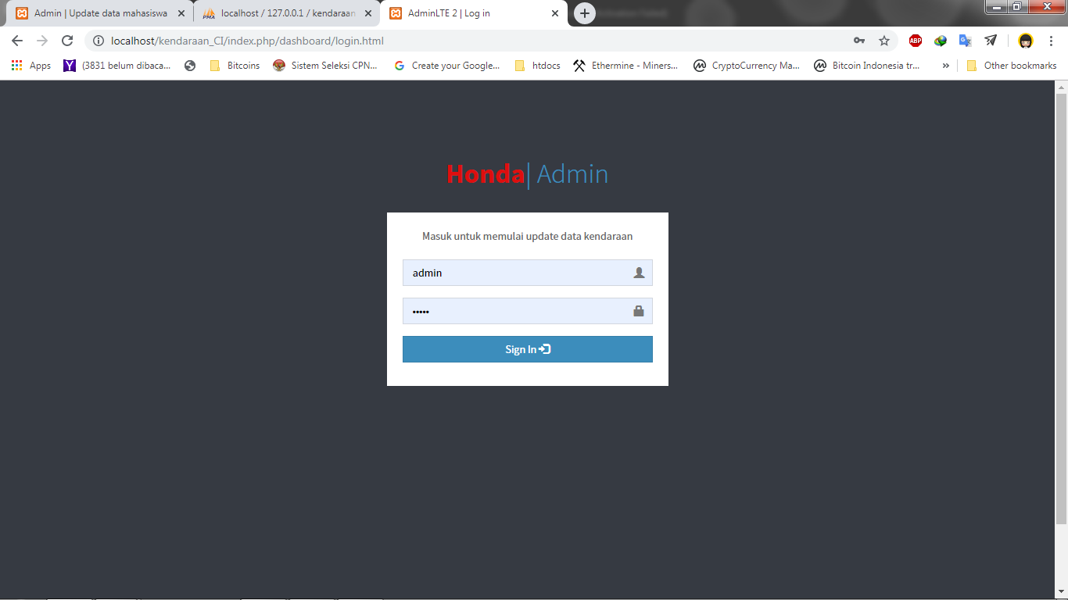

* 1. **Halaman transaksi penjulan dan pembelian kendaraan.**

Halaman ini berisikan tanggal dan total dari satu hari tersebut yang dipisahkan per tanggal penjualan maupun pembelian.

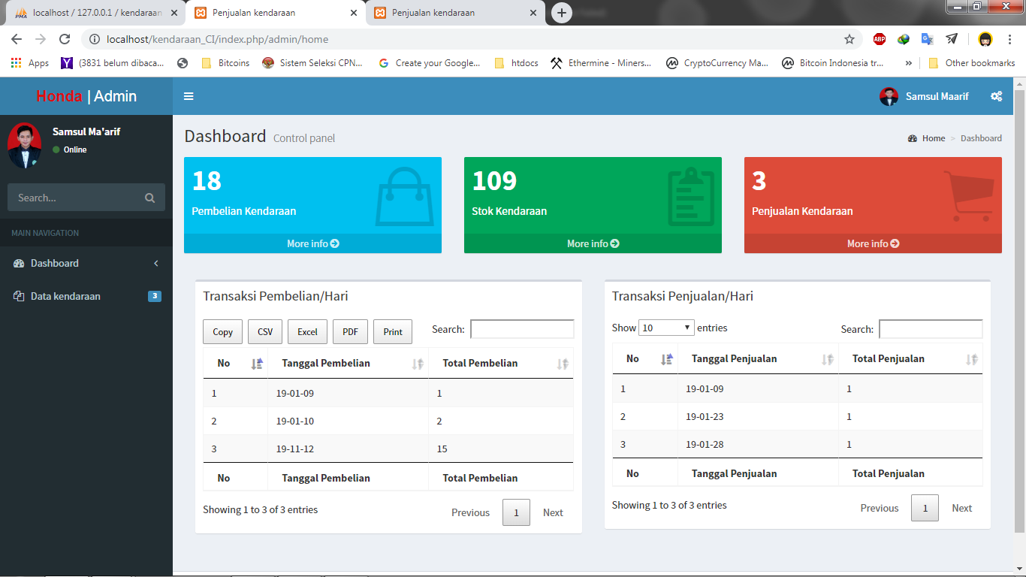

* 1. **Halaman pembelian kendaraan**

Dihalaman pembelian ini berisikan transaksi pembelian kendaraan admin ke dealer pusat

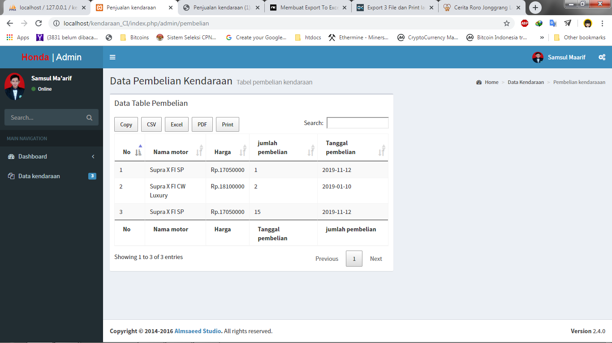

Admin harus masuk ke halaman stok terlebih dahulu untuk mengetahui stok kendaraan mana yang harus ditambah atau dibeli, admin diharuskan memasukkan kode kendaraan dan jumlah pembelian unit.

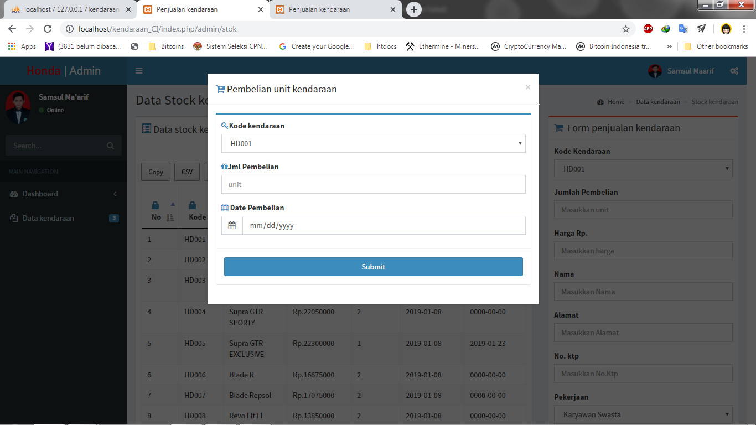

* 1. **Halaman stok kendaraan**

Di halaman ini berisikan data stok kendaraan yang tersisa yang berisikan kode kendaraan, nama, harga, stok, tanggal pembelian terakhir dan penjualan terakhir.

Pada from penjualan kendaraan ini berguna apabila ada pembeli yang berniat untuk membeli kendaraan maka admin terlebih dahulu harus menginputkan data pemebeli tersebut dan secara otomatis stok kendaraan akan berkurang, serta transaksi tersebut akan direkam dan ditampilkan di halaman penjualan kendaraan.

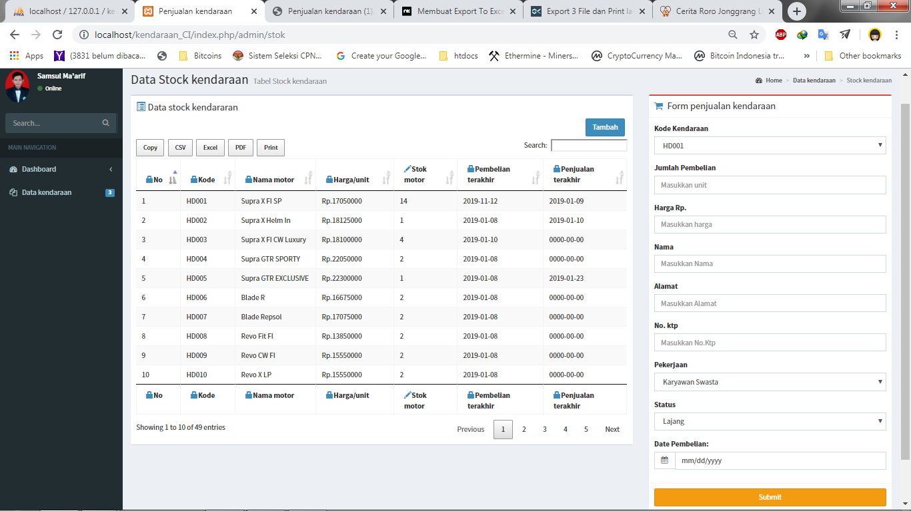

* 1. **Halaman penjualan kendaraan**

Pada halaman penjualan ini berisikan transaksi penjualan kendaraan kepada pembeli dengan berisikan alamat serta data diri pembeli dan harga kendaraan yang dibeli oleh pembeli tersebut.

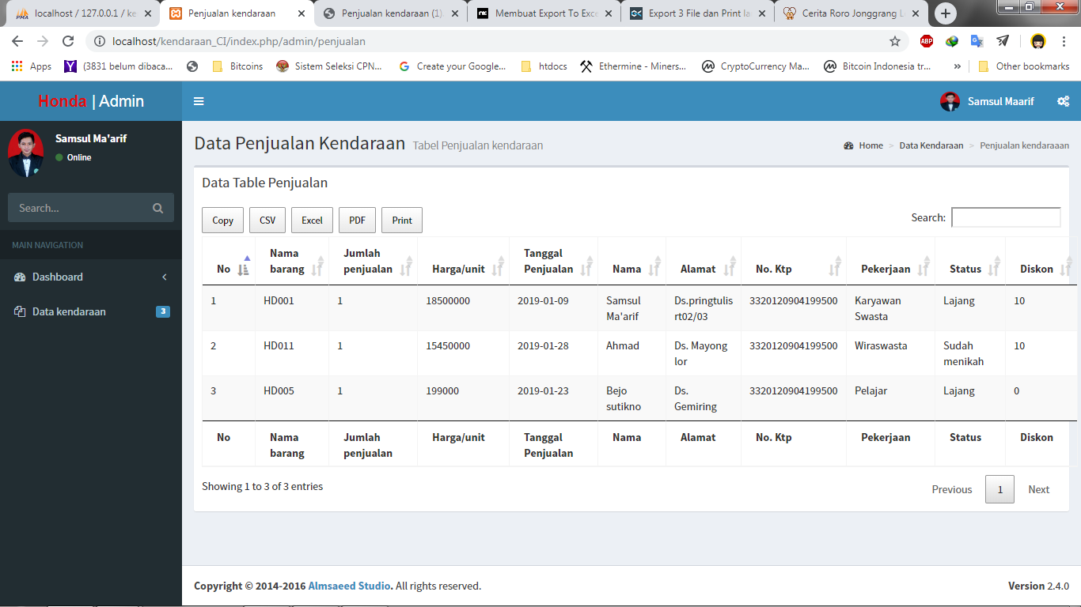

* 1. **Vendor data tables**

<https://datatables.net/extensions/buttons/examples/initialisation/export.html>